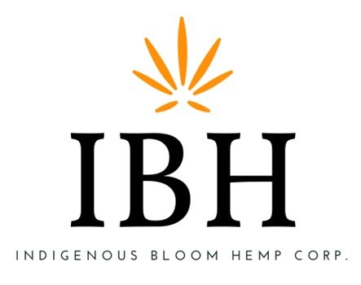
Indigenous Bloom Hemp Corp. confirms the filing of audited financial statements, announces Board resignations, and announces a potential strategy shift for grow operations.

VANCOUVER, British Columbia, December 1, 2022 – Indigenous Bloom Hemp Corp. (the “Company” or “Indigenous Bloom”) announces that it filed its audited financial statements for the year ended May 31, 2022, on Monday November 28, 2022, including the related management discussion and analysis and CEO and CFO certifications (collectively, the Annual Financial Filings). It anticipates being able to file its Q1 interim financials for the three-month period ending August 31, 2022 by December 5, 2022.
The Company also announces the resignation of Peter McFadden as CFO effective November 30, 2022. Mr. McFadden’s contribution to the Company was instrumental in assisting Indigenous Bloom in navigating and accelerating the Company’s ability to pave a new path. The Company would like to thank him for his contributions and for achieving his strategic objectives during an important phase of Indigenous Bloom’s growth.
Mr. Chris Federowich and Mr. Larry Dykstra have informed the Company of their decision to resign as Board Directors so that they may pursue other interests with immediate effect.
Indigenous Bloom’s CEO, Mr. Mark Roseborough commented that “The Company wishes Mr. McFadden, Mr. Federowich and Mr. Dykstra well in their future endeavors, and the Company has commenced a search to identify a new Chief Financial Officer and Board replacements.”
Furthermore, Mr. Roseborough commented that “due to market conditions and the challenges of climate change, Indigenous Bloom will be investigating options for shifting the company’s grow operations from outdoor cultivation to a more streamlined indoor grow operation. This shift would allow Indigenous Bloom to be able to consistently produce high quality product with the ultimate goal of extracting superior components.”
About Indigenous Bloom Hemp Corp.
For the past 3 years, Indigenous Bloom Hemp Corp. has operated a large-scale industrial hemp farm in Southern Manitoba on approximately 250 acres of zoned farmland. The Company's primary focus is the processing and sale of hemp biomass, flower, and phytocannabinoid rich extracts derived from hemp biomass. Indigenous Bloom Hemp Corp.'s vision is to become a premium producer of CBD oils, distillate or isolate and produce health supplements, nutritional products, food and beauty products, and to market it initially in Canada and eventually globally.
Indigenous Bloom Hemp Corp. is a publicly traded company in Canada, on the Canadian Securities Exchange under the ticker IBH; in the United States, on the OTC under the ticker VRTHF; and in Germany, on the Frankfurt exchange under the ticker 2VP0.
On behalf of the Board of Directors
"Lorne Mark Roseborough"
Chief Executive Officer
Further information about the Company is available under our profile on SEDAR at www.sedar.com, and on the CSE website at www.thecse.com.
Investor and Public Relations Contact
Indigenous Bloom Hemp Corp.
Telephone: +1.416.918.6785
Email: info@plutusbridge.com
The CSE has not reviewed, nor approved or disapproved the content of this press release.

